A000-EUR-Rome-Glass-Goblet-100 CE

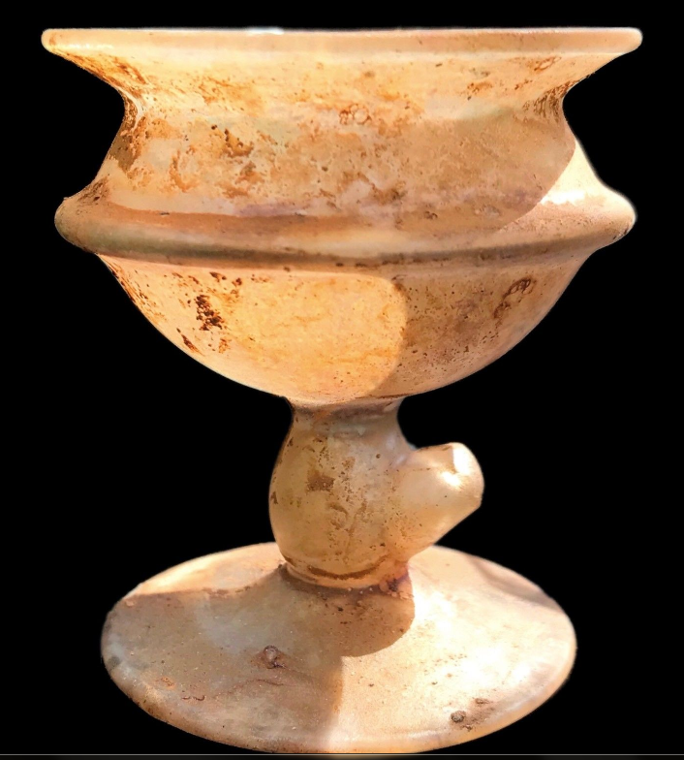

**Case No.:**

**Accession No.**

**Formal Label:**

**Display Description:**

**Accession Number:**

**LC Classification:**

**Date or Time Horizon:**

**Geographical Area:**

**Map:**

**GPS coordinates:**

**Cultural Affiliation:**

**Media:**

**Dimensions:** Height: 6.8 cm

**Weight:** Weight: 29 grams

**Condition: Original.** This Chalice Has a Small Break to the Bottom Shown in Picture

**Provenance:** Private 1980s London Collection.

**Discussion:**

**References:**